🎯 Goal
Build a pipeline using Jenkins that:
1️⃣ Pulls Node.js code from GitHub
2️⃣ Builds Docker image
3️⃣ Pushes image to Docker Hub
4️⃣ Deploys to Kubernetes (Minikube)
5️⃣ Enables Horizontal Pod Autoscaling (HPA)
Structure:
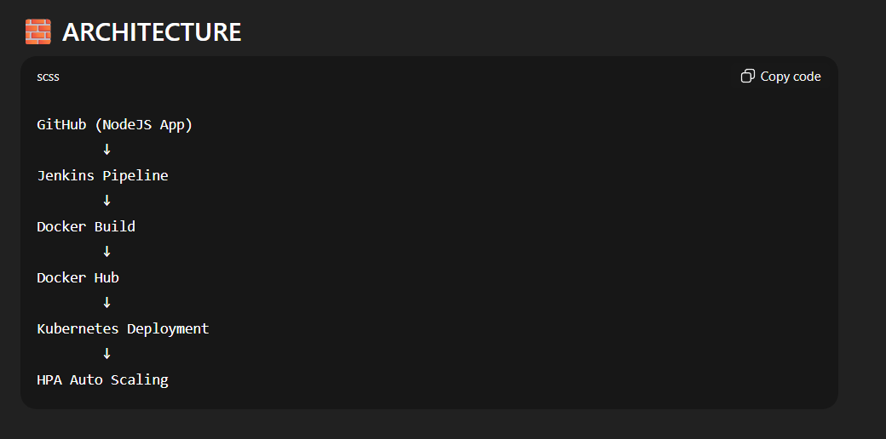

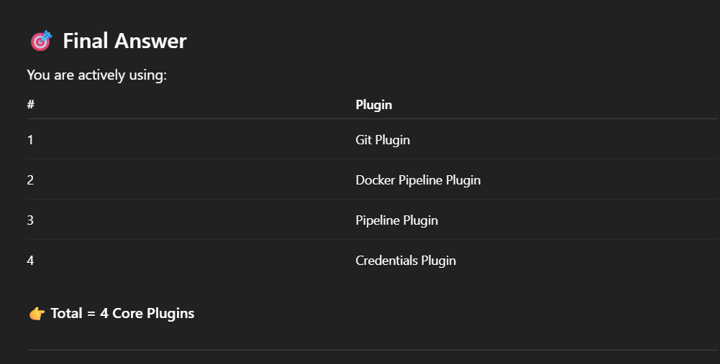
- Step:
Install all requisite tools:

- Java
sudo apt update
sudo apt install fontconfig openjdk-21-jre
java -version

- Jenkins
sudo wget -O /etc/apt/keyrings/jenkins-keyring.asc \
https://pkg.jenkins.io/debian-stable/jenkins.io-2026.key
echo "deb [signed-by=/etc/apt/keyrings/jenkins-keyring.asc]" \
https://pkg.jenkins.io/debian-stable binary/ | sudo tee \
/etc/apt/sources.list.d/jenkins.list > /dev/null
sudo apt update
sudo apt install Jenkins

- Git
sudo apt install git

- Docker
sudo apt install docker.io

- Kubernetes
sudo apt-get update
# apt-transport-https may be a dummy package; if so, you can skip that package
sudo apt-get install -y apt-transport-https ca-certificates curl gnupg
# If the folder `/etc/apt/keyrings` does not exist, it should be created before the curl command, read the note below.
# sudo mkdir -p -m 755 /etc/apt/keyrings
curl -fsSL https://pkgs.k8s.io/core:/stable:/v1.35/deb/Release.key | sudo gpg --dearmor -o /etc/apt/keyrings/kubernetes-apt-keyring.gpg
sudo chmod 644 /etc/apt/keyrings/kubernetes-apt-keyring.gpg # allow unprivileged APT programs to read this keyring
# This overwrites any existing configuration in /etc/apt/sources.list.d/kubernetes.list
echo 'deb [signed-by=/etc/apt/keyrings/kubernetes-apt-keyring.gpg] https://pkgs.k8s.io/core:/stable:/v1.35/deb/ /' | sudo tee /etc/apt/sources.list.d/kubernetes.list
sudo chmod 644 /etc/apt/sources.list.d/kubernetes.list # helps tools such as command-not-found to work correctly
sudo apt-get update
sudo apt-get install -y kubectl

- Minikube:
curl -LO https://storage.googleapis.com/minikube/releases/latest/minikube_latest_amd64.deb
sudo dpkg -i minikube_latest_amd64.deb

- Step:
Set Jenkins setup.
Ip:8080
Ask for password.
sudo cat /var/lib/jenkins/secrets/initialAdminPassword
copy and paste.
Install suggested plugins.
Set username and password. Jenkins will be ready.

- Step:
Update visudo and assign administration privileges to jenkins user and other accesses
sudo nano /etc/sudoers
Add the following line at the end of the file
jenkins ALL=(ALL) NOPASSWD: ALL
After adding the line save and quit the file.
Now we can use Jenkins as root user and for that run the following command -
sudo su - jenkins
Jenkins will be accessing the Docker for building the application Docker images, so we need to add the Jenkins user to the docker group.
sudo usermod -aG docker jenkins
sudo systemctl restart jenkins

ensure Jenkins can run kubectl
sudo cp ~/.kube/config /var/lib/jenkins/
sudo chown jenkins:jenkins /var/lib/jenkins/config

ensure Jenkins have docker hub access.
set credentials and install docker pipeline plugin

in Jenkins account create yaml files.
mkdir k8s
cd k8s
nano deployment.yaml
nano service.yaml
nano hpa.yaml

- Step:
Start minikube
minikube start --driver=docker
minikube addons enable metrics-server
kubectl get nodes

- Step:
Create node js application with npx react-create-app demoapp

- Step:
FROM node:18-alpine
WORKDIR /app
COPY package*.json ./
RUN npm install
COPY . .
EXPOSE 3000
CMD ["npm", "start"]

- Step:
Test your docker build:
docker build -t node-app:test .
docker run -p 3000:3000 node-app:test

- Step:
push the code in github

- Step:
Create Jenkins project selecting pipeline.
Make Jenkins groovi script and then build

